Task 01::
65 ÷ 2 = 32 remainder 1
32 ÷ 2 = 16 remainder 0
16 ÷ 2 = 8 remainder 0
8 ÷ 2 = 4 remainder 0
4 ÷ 2 = 2 remainder 0
2 ÷ 2 = 1 remainder 0
1 ÷ 2 = 0 remainder 1
A -> 1 0 0 0 0 0 1

B->
📘 Details:
- Decimal: 97
- Binary:
  - 97=64+32+1 = 2^6 + 2^5 + 2^0
  - So binary is: 1100001
Task 3:

Types of Computer memory with examples.. Explain ..
Task 3: Types of Computer Memory
- Primary Memory – Fast, used by CPU, temporary
  - RAM – Stores running programs, data gone when power off (e.g., 8GB RAM)
  - ROM – Stores boot info, permanent (e.g., BIOS)
- Secondary Memory – Slower, permanent storage
  - HDD – Hard disk (e.g., 1TB drive)
  - SSD – Faster storage (e.g., 512GB SSD)
  - CD/DVD – Optical disks
  - USB Drive – Portable flash memory
- Other Types
  - Cache – Small, very fast memory inside CPU
  - Virtual Memory – Uses hard disk as extra RAM
Task 4:

Data structures are ways to store and organize data in a computer so it can be used efficiently.
They help in:
- Storing data properly
- Accessing and updating data quickly
- Solving problems faster
Task 5::
Common operations are: insertion, deletion, traversal, searching, and sorting.
Task 6 ::
Feature | Static Array | Dynamic Array
Size | Fixed at creation | Can grow or shrink during runtime
Memory | Allocated at compile time | Allocated at runtime
Flexibility | Less flexible | More flexible
Example | int arr[5]; (in C/C++) | ArrayList in Java, list in Python
Task7::
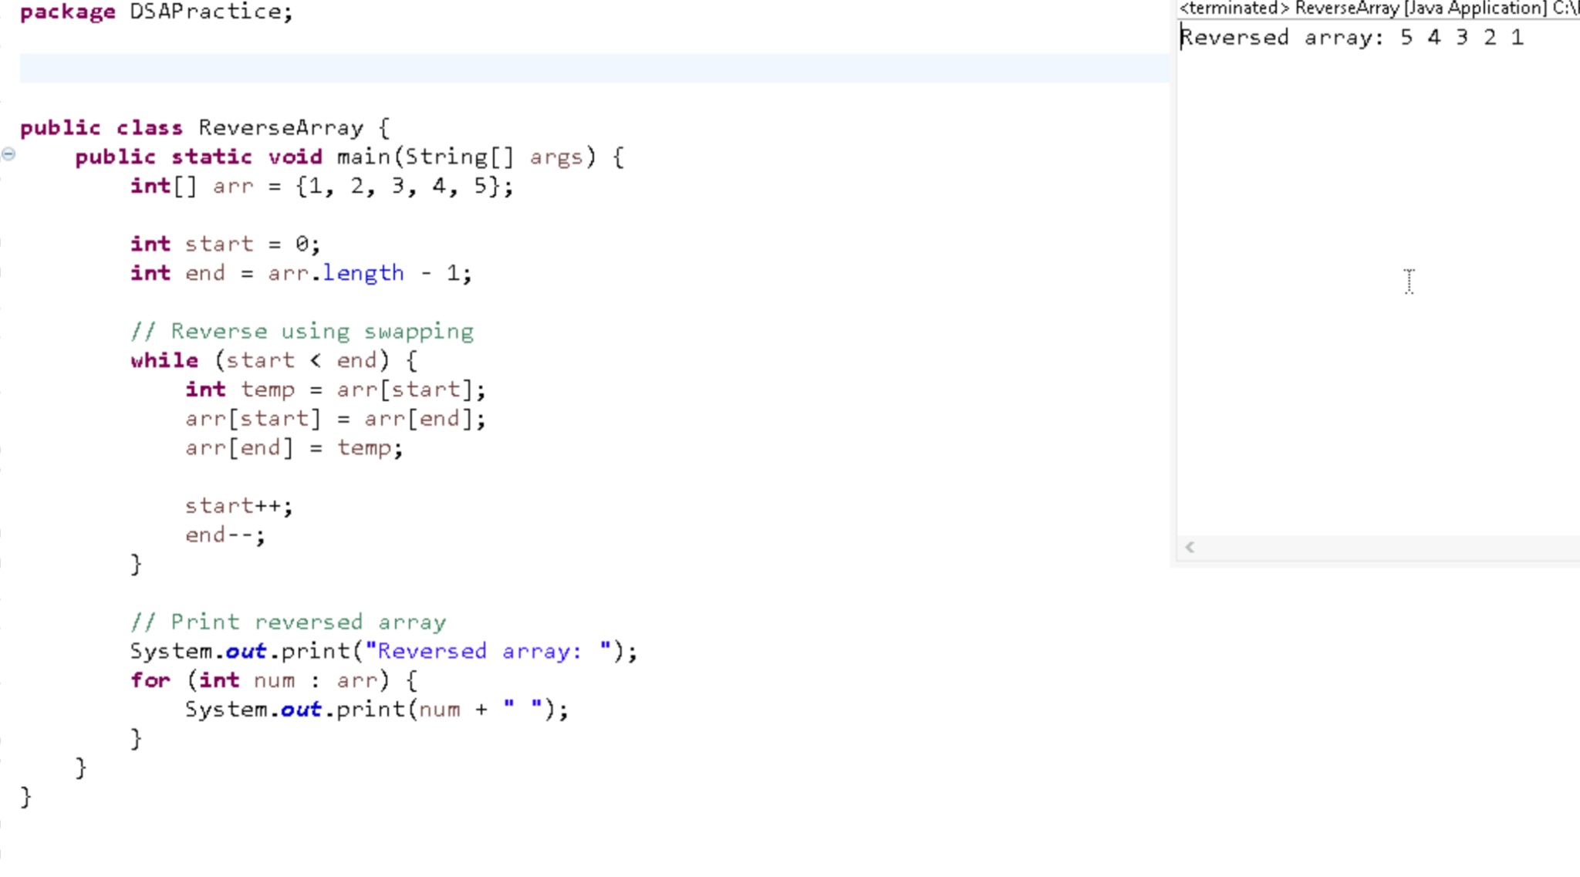

Task8::
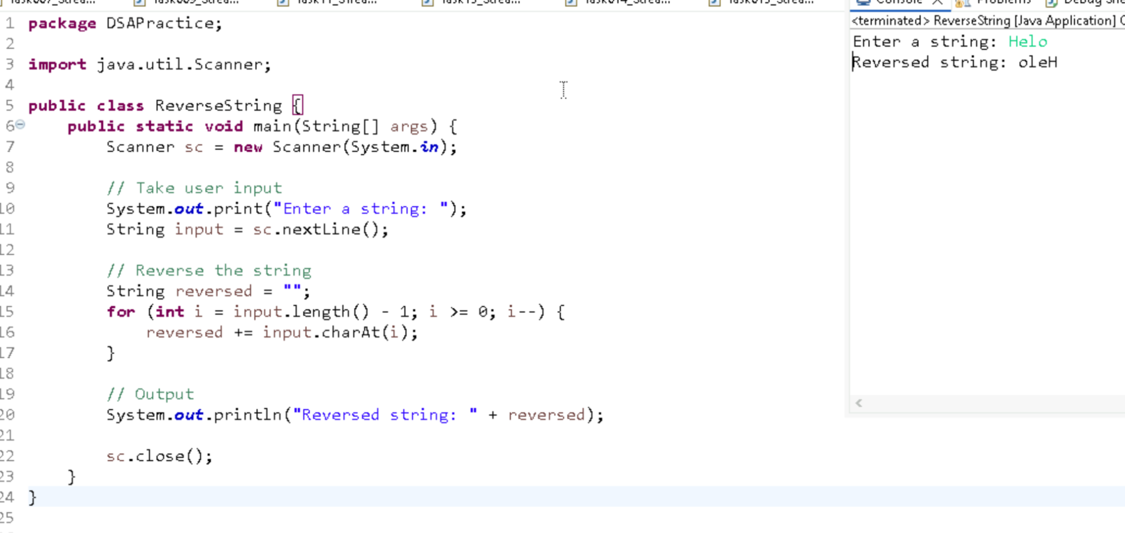
Task10::
Merging 2 sorted arrays, compare and add values to merge array, while loop is to copy any left over items in arrays
Task 11::
A Hash Table is a data structure that stores data in key-value pairs.
It uses a hash function to convert the key into an index, where the value is stored.
Task12::
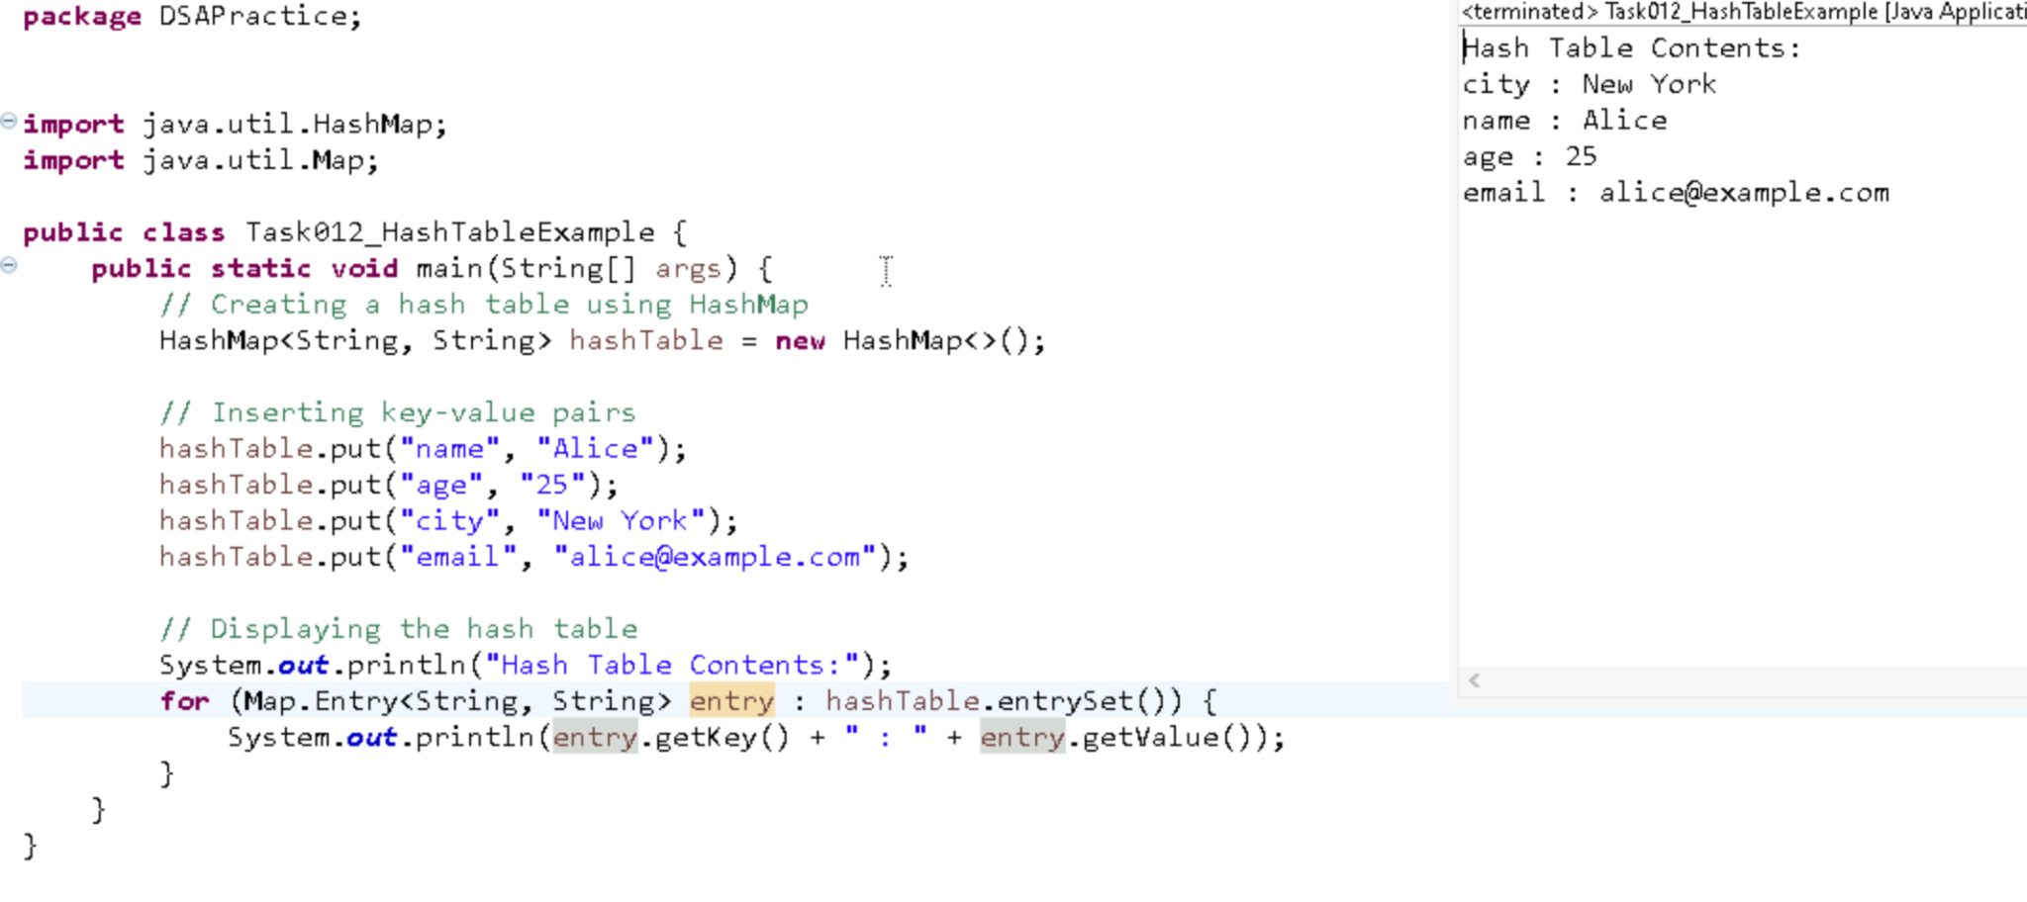

Task14::

Advantages | Disadvantages
Fast average-case operations (O(1)) | Poor worst-case performance (O(n))
Efficient lookups | Collisions require resolution strategies
Flexible key types | No ordering of elements
Suitable for dynamic data | Resizing is costly (rehashing)
Optimized memory usage (with good hash) | Depends on a good hash function

Task 15::
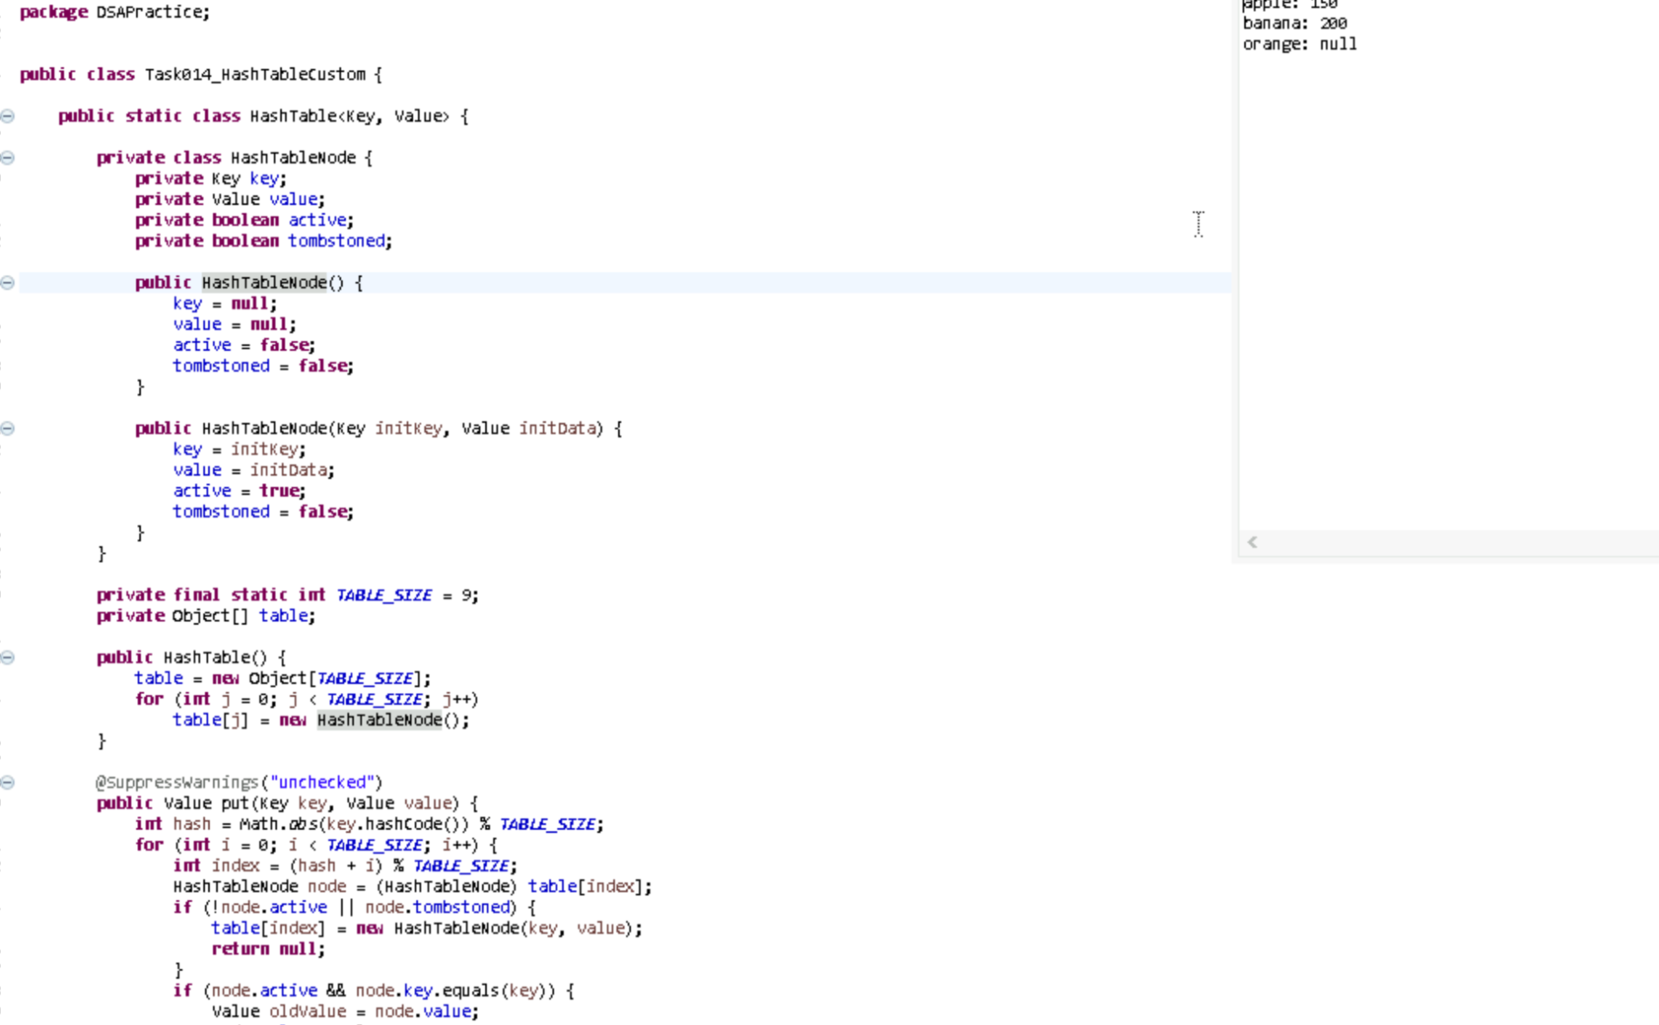

Task16 ::
The Hashtable class in Java provides several useful methods: put() to insert or update key-value pairs, get() to retrieve a value by key, remove() to delete a key-value pair, containsKey() and containsValue() to check for the presence of keys or values, isEmpty() to check if the table is empty, size() to get the number of entries, and clear() to remove all entries. For traversing, it offers keySet(), values(), and entrySet() to access keys, values, or key-value pairs respectively. Additionally, clone() creates a shallow copy, equals() compares two hash tables, and hashCode() returns the hash code of the table.
Task18::
1. **Storage Structure**
HashMap uses an array of **buckets**, where each bucket stores entries as a **linked list** or a **tree** (if many entries hash to the same index).

Structure:
- Array of Node<K, V>
- Each Node stores: key, value, hash, and next (pointer to the next node)

2. **Hashing**
When you call `put(key, value)`, HashMap:
- Computes the hash of the key
- Uses `hash % capacity` to find the index
- Inserts the entry in that bucket (as the first node or linked behind existing ones)

3. **Collision Handling**
If two keys hash to the same index:
- They are stored in the same bucket using a linked list
- If a bucket becomes too large (≥ 8 entries), it converts the list to a **balanced tree** (Red-Black Tree)

4. **Rehashing**
When load factor exceeds threshold (default 0.75), the capacity doubles and all entries are **rehashed** to new buckets.

5. **Retrieving with get(key)**
- HashMap computes the hash
- Goes to the bucket index
- Traverses linked list or tree to find the matching key

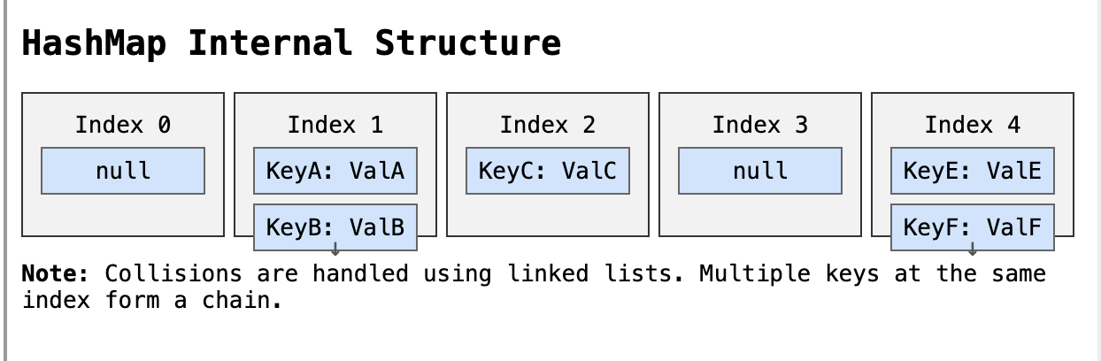

Example flow:
- put("KeyA", "ValA") → hash → index 1 → insert at Bucket1
- put("KeyB", "ValB") → same index → chain to Bucket1
- get("KeyB") → hash → index 1 → search chain → match key

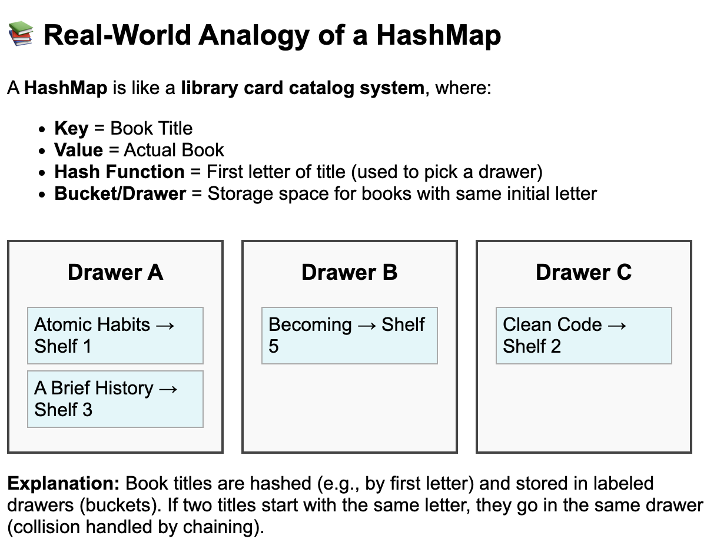

Task19::
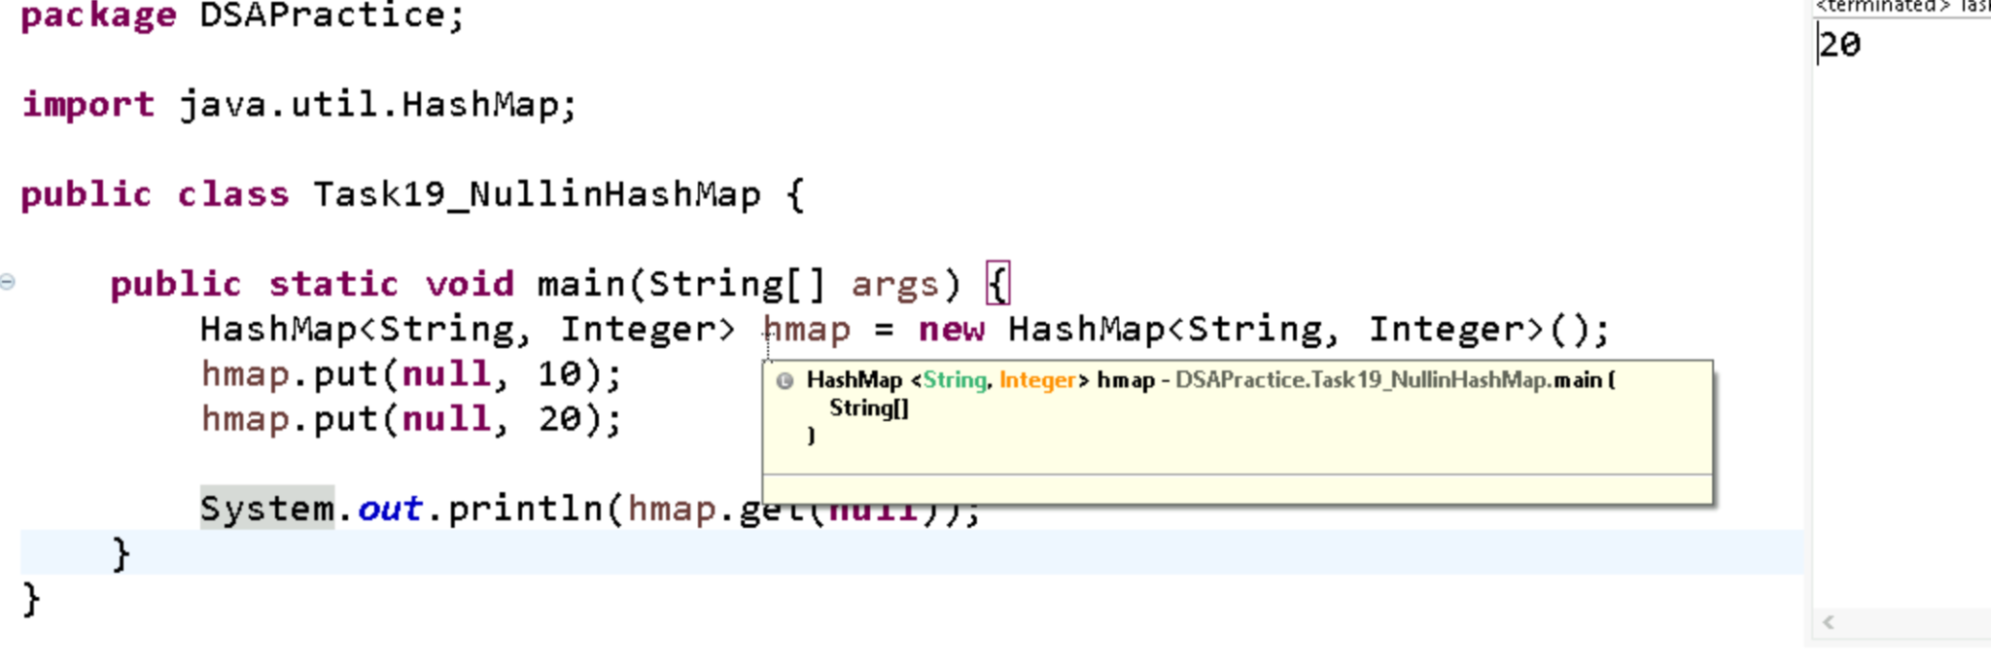

Task 20:

How many methods are there to create a hash Map?
Method # | Approach | Mutable | Java Version
1 | Default constructor | ✅ | All
2 | With initial capacity | ✅ | All
3 | With capacity + load factor | ✅ | All
4 | Copy from existing map | ✅ | All
5 | Map.of() + HashMap | ✅ | 9+
6 | Java Streams | ✅ | 8+

Task21::
Map<String, Integer> syncMap = Collections.synchronizedMap(new HashMap<>());

synchronized (syncMap) {
for (Map.Entry<String, Integer> entry : syncMap.entrySet()) {
System.out.println(entry.getKey() + ": " + entry.getValue());
}
}

